EXERCISE NO. 2 PART 1 (WEEK4)
REAL ESTATE WEBSITE

OBJECTIVE: To design a real estate website exploring HTML image map, layouts and CSS

Instructions:

- Design a three page web site for a real estate company .

- Place ALL your files in one folder and save the folder as: surname_ex2. The main page should have a filename of surname: ex2.html. On done with this exercise, save folder in the link provided

- The home page must contain the following html element stated below. Style rules and design principles discussed must be observed.
- Declare elements (headings, lists, paragraph) and add internal styles (font style , color, alignment, sizes)
- Add indent on all paragraphs (use internal CSS)
- Add appropriate background image (use internal CSS)
- Add left and right margin on all web pages (set your own value)
- Add font style , color, font-fallback, italic, bold, underline, etc
- Observe html5 layout (header, nav, section, footer)
- Observe consistency on all navigations.
- Ensure contents are readable

Mainpage
REAL LIVING Real Estate

About Us:
Real Living Real Estate is a full-service real estate brokerage franchise company with a comprehensive and integrated suite of resources for franchisees and their sales professionals, as well as for consumers who work with them. In 2016 and 2017, Real Living Real Estate was named "Real Estate Agency Brand of the Year" in the ongoing Harris Poll EquiTrend® study; and was named "Most Loved" and "Most Trusted" real estate brand in the study in consecutive years. Additionally, the Real Living Brand and its innovative concepts were recognized by Entrepreneur magazine as well as Inman News, receiving several Inman Innovator Awards. Real Living was also named "the Most Promising New National Brand" by the Swanepoel TRENDS Report. Real Living Real Estate is a network brand of HSF Affiliates LLC, which is owned by HomeServices of America, Inc., a Berkshire Hathaway affiliate.
Real Living leads the real estate industry with a customer satisfaction rating of 98 percent, based upon research conducted by a third party, independent research firm*.
Based in Minneapolis, Minn., HomeServices of America, Inc. is the second-largest, full-service residential real estate brokerage firm and the largest brokerage-owned settlement services provider in the U.S. and is the majority owner in the Prudential Real Estate and Real Living Real Estate franchise networks. Owned by MidAmerican Energy Holdings Company, a consolidated subsidiary of Berkshire Hathaway Inc., HomeServices' operating companies offer integrated real estate services, including brokerage services, mortgage originations, title and closing services, property and casualty insurance, home warranties and other homeownership services.
<add related images here>

Second page (save as page2.html):

Contains the image map of a floor plan (see image below). The floor plan must have at least three hotspots linked to dining, living, master page (provided -see folder). Use rectangle or polygon. Hotspots must be appropriate and accurate. Each page must have appropriate image and content. Design a unified theme on all pages (edit dining, living, master page according to your chose design theme)

View our latest bungalow home:
- Add other details here..
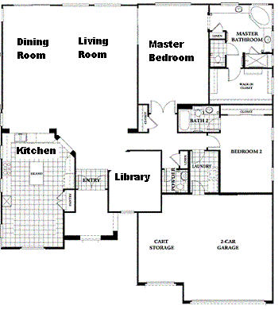

EXERCISE NO. 2 PART 2 (WEEK5)
REAL ESTATE WEBSITE (continuation)

OBJECTIVE: To design a real estate website exploring HTML forms.

Instruction:
Third page (save as page3.html):
- Create an application form containing related contents and html elements stated below:

- 10Textbox
- 5 Radio buttons (in two categories)
- 5 Checkbox (in two categories
- At least 3Selection box (with at least 4 choices)
- 4 Textarea
- At least 5 Fieldset with legend
- 1 Submit button
- 1 Reset button
- 1 Input type Date
- 1 Search bar
- Datalist
- Input type number
- Input type Email
- Etc..

